CMPS 350- Web Development Fundamentals

**Assignment 1**

|  |  |
| --- | --- |
| **Student Name** | **SYED AHMAD FARAZ SUBZWARI** |
| **Student Id** | **202105006** |
| **Email** | **SS2105006@qu.edu.qa** |

**Grading Rubric - - In the *Functionality* column please specify either: *Working (completed x%)*, *Not Working (completed x%)* or *Not done*.**

|  |  |  |  |  |
| --- | --- | --- | --- | --- |
| Criteria | % | Functionality* | Quality of the implementation (Instructor Feedback) | Score |
| -Used proper HTML-5 Tags and Semantic for all the three pages [30] | 40 | ***Working (completed 100%)*** |  | 40 |
| -Correctly replicated the page design  -Made all the two pages Responsive using media queries , flex-box and Grid | 60 | ***Working (completed 100%)*** | Works as expected. The structure of CSS code in some areas should have started with the class name rather than IDs. | 59 |
| Did Not Submit the testing sheet | -10 |  |  |  |
| Total | 100 | ***Working (completed 100%), Final grade is 99%*** | Final Grade is 99% out of 100. | 99 |
| Copying and/or plagiarism or not being able to explain or answer questions about the implementation | -100 |  |  |  |

**Possible grading for functionality**:

* ***Complete and Working*** (get 70% of the assigned grade),
* ***Complete and Not working*** (lose 60% of assigned grade)
* ***Not done*** get 0.
* The remaining grade is assigned to the quality of the implementation.
* Must submit screenshots in this **Testing-GradingSheet.docx** (otherwise - 10pts).

## Testing evidence

Add the screenshots of your working website here.

**ON THE NEXT PAGES:**

**NOTE: I could make CSS way more efficient but at the cost of readability, however, I would like to preserve readability (tree-structure) with some efficiency. I feel this helps me. Also, I had to set my browser size for the phone a bit higher as my browser wouldn’t shrink and it helps demonstration.**

## Home page

## Big Screen

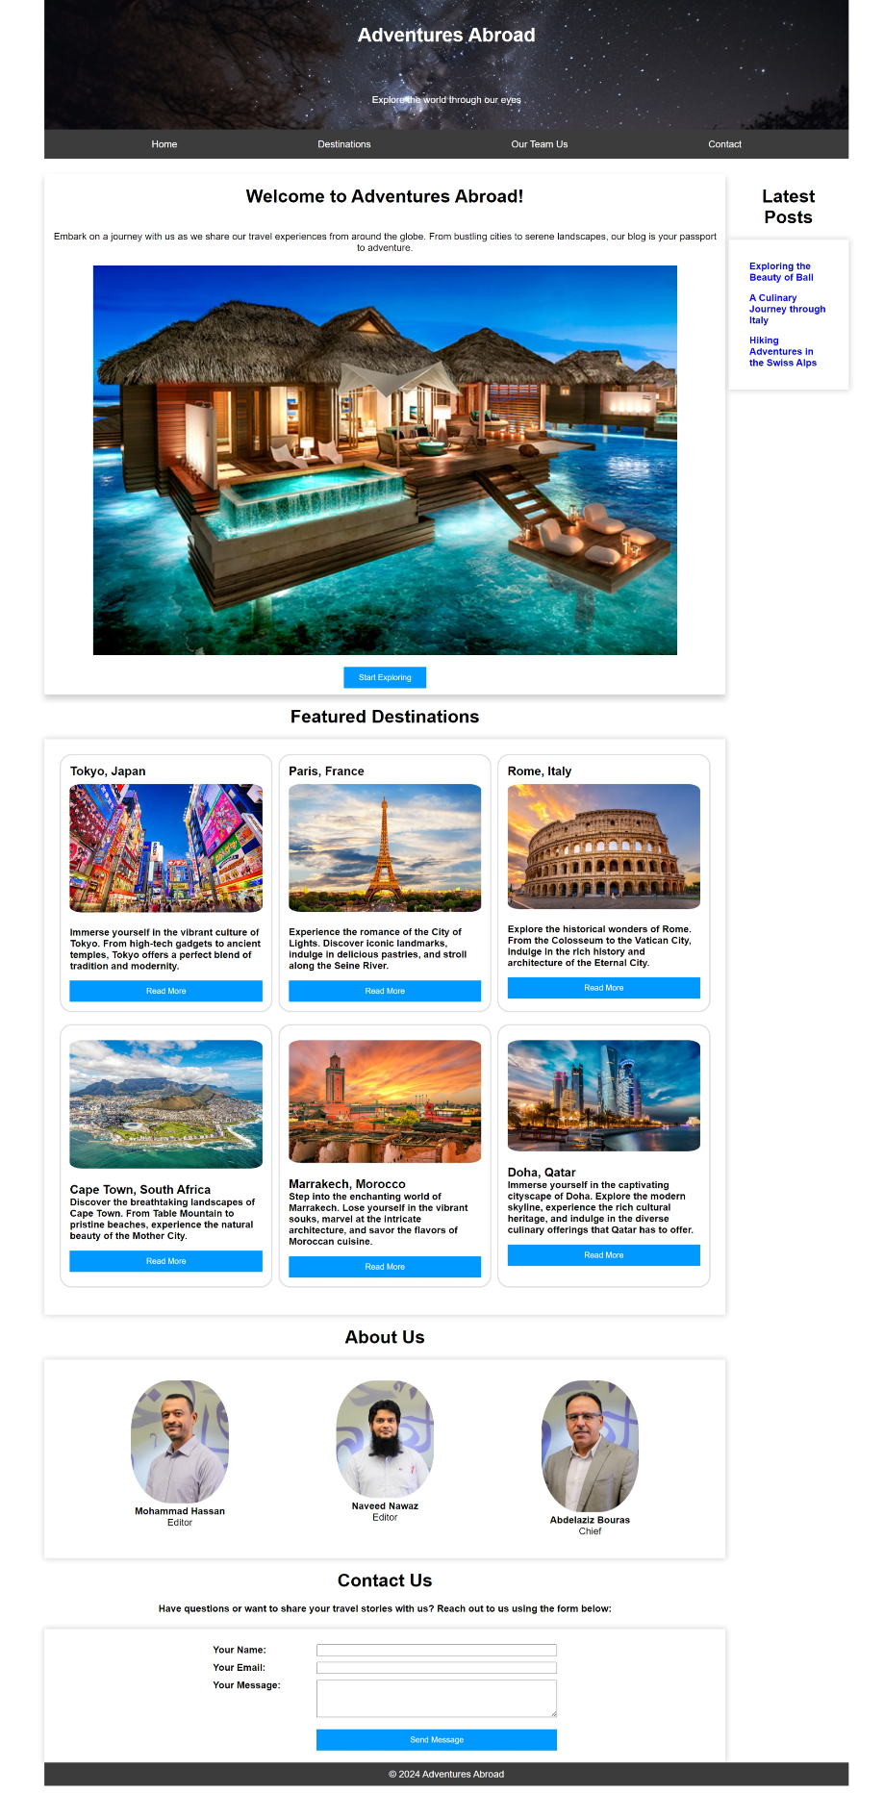**FULL PAGE OVERVIEW BIG SCREEN:**

**EVIDENCE OF RAM TECHNIQUE:**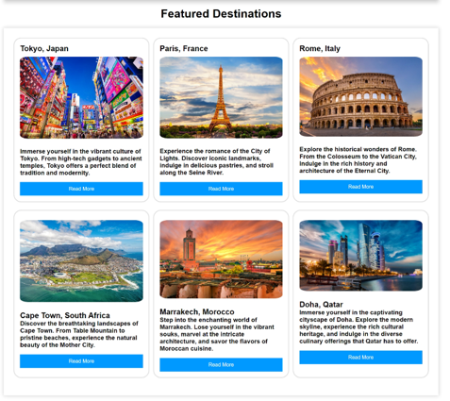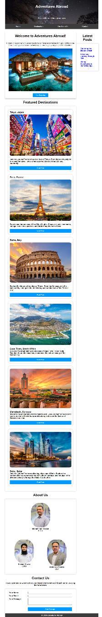

**EVIDENCE OF ABOUT US SECTION RESIZING:**

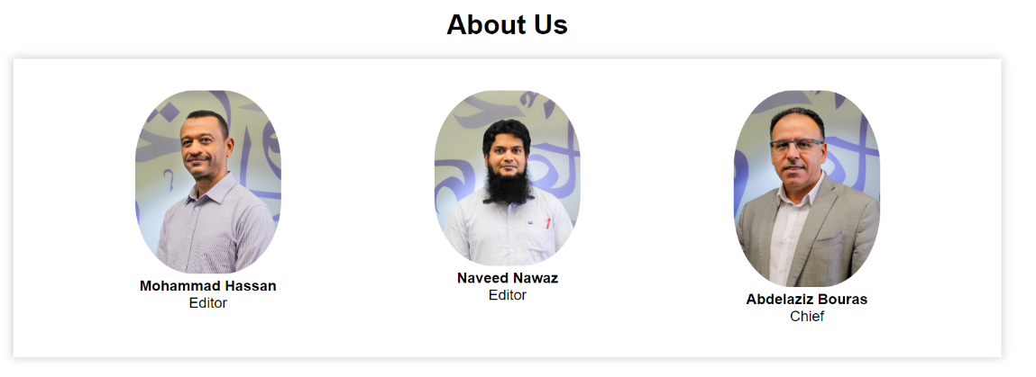

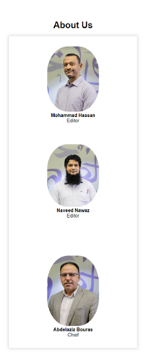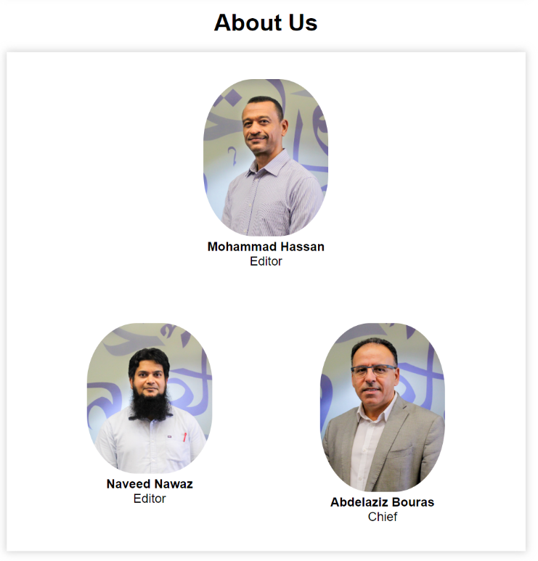

## Small Screen

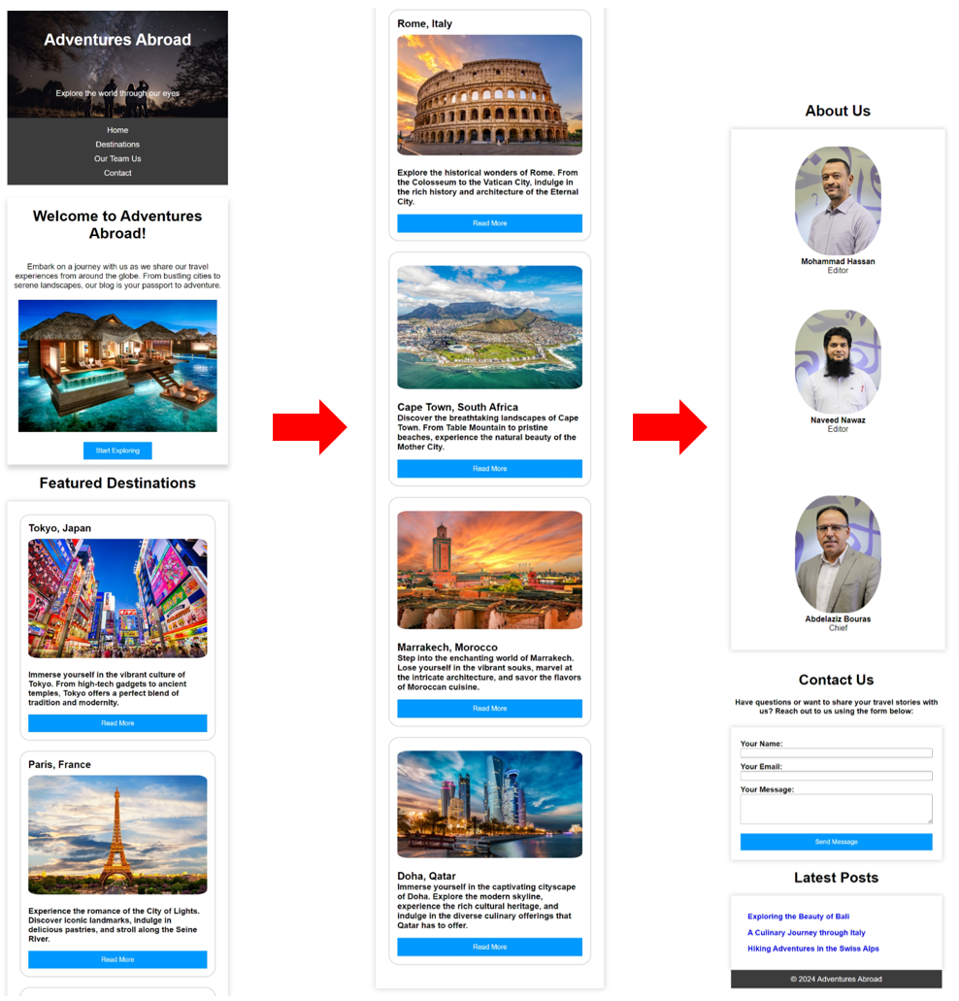**FULL PAGE OVERVIEW SMALL SCREEN:**